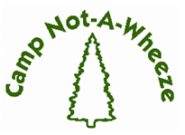
2026 Program Report

CAMPER DATA
Table #1 Camper Home Location by County
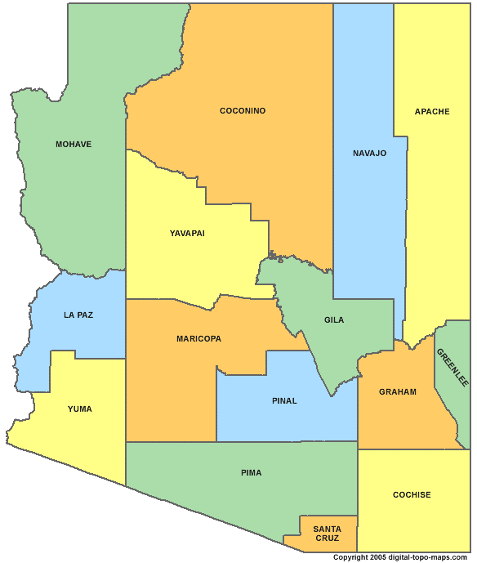
66.1%
1.7%

County | # of Campers | Percentage
Pinal | 3 | 5%
Maricopa | 39 | 66.1%
Yuma | 1 | 1.7%
Mohave | 1 | 1.7%
Navajo | 8 | 13.6%
Pima | 1 | 1.7%
Coconino | 1 | 1.7%
Yavapai | 2 | 3.4%
Gila | 1 | 1.7%
Apache | 2 | 3.4%
Total | 59 | 100%
* Data Source: Camp Not-A-Wheeze 2026 Camper
1.7%
3.4%
13.6%
5%
1.7%
3.4%
1.7%
1.7%
applications.

Table #2 Camper Ethnicity/Race

Ethnicity/Race | # of Campers | Percentage
Hispanic or Latino | 17 | 29%
Native American | 14 | 23.7%
Non-Hispanic, White | 17 | 29%
Black or African American | 11 | 18.6%
Asian | 0 | 0%
Total | 59 | 100%
* Data Source: Camp Not-A-Wheeze 2026 Camper
Applications.

Table #3 Gender Distribution

Gender | # of Campers | Percentage
Female | 23 | 39%
Male | 36 | 61%
Total | 59 | 100%
*Data Source: Camp Not-A-Wheeze 2026 Camper Applications.

Table #4 Age Distribution

Age | # of Campers | Percentage
7 years old | 0 | 0%
8 years old | 5 | 8.5%
9 years old | 10 | 16.8%
10 years old | 9 | 15.3%
11 years old | 9 | 15.3%
12 years old | 6 | 10.2%
13 years old | 7 | 11.9%
14 years old | 3 | 5%
15 years old | 4 | 6.8%
16 years old | 4 | 6.8%
17 years old | 2 | 3.4%
Total | 59 | 100%
* Data Source: Camp Not-A-Wheeze 2026 Camper
Applications. Does not include the ages of the CIT’s

Table #5 Camper Annual Income
Household Annual Income in USD | # of Camper Families | Percentage
0-20,000 | 20 | 34%
20,000 – 30,000 | 10 | 17%
30,000 – 40,000 | 3 | 5%
40,000 – 50,000 | 4 | 6.8%
50,000 – 60,000 | 1 | 1.7%
60,000-70,000 | 1 | 1.7%
70,000-80,000 | 0 | 0%
80,000-90,000 | 2 | 3.4%
90,000-100,000 | 3 | 5%
>100,000 | 5 | 8.5%
Unknown | 10 | 16.9%
Total | 59 | 100%

* Data Source: Camp Not-A-Wheeze 2026 Campership Applications.

Table #6 Camper Health Insurance

Health Insurance | # of Campers | Percentage
AHCCCS | 30 | 51%
Private Health Insurance | 26 | 44%
Native American Health Services | 2 | 3.3%
Uninsured | 1 | 1.7%
Total | 59 | 100%
Data Source: Camp Not-A-Wheeze 2026 Camper Applications.

Table #7 Campers on Scholarship

Scholarship | # of Campers | Percentage
Received Scholarship | 44 | 74.6%
Financial Discount | 12 | 20.3%
Did Not Qualify or Request a Scholarship | 3 | 5.1%
Total | 59 | 100%
* Scholarships are granted based on information provided
in Camp Not-A-Wheeze 2026 Campership Applications.

Table #8 New Campers vs Previous Campers

Has Child Attended CNAW in Previous Years | # of Campers | Percentage
Yes | 39 | 66.1%
No | 20 | 33.9%
Total | 59 | 100%
Data Source: Camp Not-A-Wheeze 2026 Camper
Applications.

Table #9 Increase in Asthma and Allergy Education in Campers CNAW 2026
* Data Source: Camp Not-A-Wheeze 2026 Camper Pre- and Post-Asthma and Allergy Education Evaluations.
Asthma and Allergy Education | Average % Correct Pre |  | Average %Correct Post | % Change
Disease/Anatomy/Physiology | 79% | 95% |  | 16%
Environment (Symptoms/Triggers) | 86% | 95% |  | 9%
Medication | 82% | 94% |  | 12%
Management | 79% | 90% |  | 11%

Table #10 Use of Technology Among Medical Volunteers
Types of Entries | Number of Entries
EMAR (Electronic Medication Administration Record) | 762
Health Log Entries | 543

*Data Source: CampDoc Electronic Reports 2026

