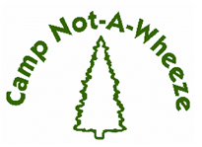
2025 Program Report

CAMPER DATA
ABQ, NM
1.6%
Table #1 Camper Home Location by County
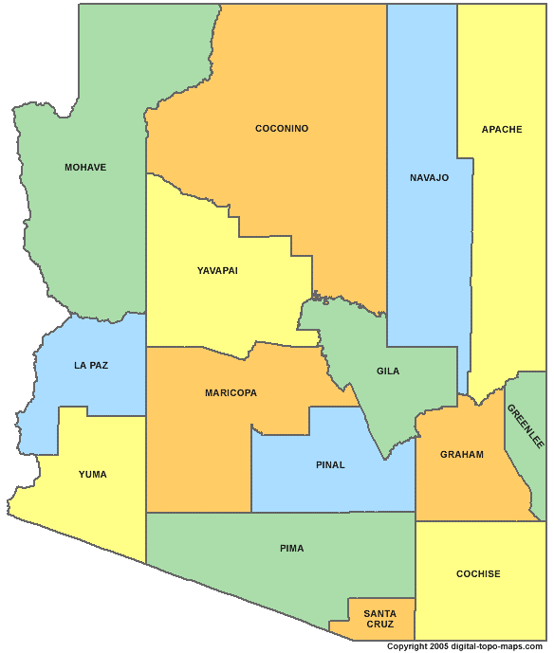
56.5%
4.8%

County | # of Campers | Percentage
Pinal | 8 | 12.9%
Maricopa | 35 | 56.5%
Yuma | 1 | 1.6%
Mohave | 1 | 1.6%
Navajo | 9 | 14.6%
Pima | 3 | 4.8%
Coconino | 1 | 1.6%
Yavapai | 3 | 4.8%
Albuquerque, NM | 1 | 1.6%
Total | 62 | 100%
* Data Source: Camp Not-A-Wheeze 2025 Camper
14.6%
12.9%
1.6%
4.8%
1.6%
1.6%
applications.

Table #2 Camper Ethnicity/Race

Ethnicity/Race | # of Campers | Percentage
Hispanic or Latino | 24 | 38.7%
Native American | 7 | 11.3%
Non-Hispanic, White | 22 | 35.5%
Black or African American | 9 | 14.5%
Asian | 0 | 0%
Total | 62 | 100%
* Data Source: Camp Not-A-Wheeze 2025 Camper
Applications.

Table #3 Gender Distribution

Gender | # of Campers | Percentage
Female | 27 | 43.5%
Male | 35 | 56.5%
Total | 62 | 100%
*Data Source: Camp Not-A-Wheeze 2025 Camper Applications.

Table #4 Age Distribution

Age | # of Campers | Percentage
7 years old | 5 | 8.0%
8 years old | 6 | 9.7%
9 years old | 7 | 11.3%
10 years old | 9 | 14.5%
11 years old | 11 | 17.7%
12 years old | 4 | 6.5%
13 years old | 3 | 4.8%
14 years old | 8 | 12.9%
15 years old | 4 | 6.5%
16 years old | 4 | 6.5%
17 years old | 1 | 1.6%
Total | 62 | 100%
* Data Source: Camp Not-A-Wheeze 2025 Camper
Applications. Does not include the ages of the CIT’s

Table #5 Camper Annual Income
Household Annual Income in USD | # of Camper Families | Percentage
0-20,000 | 8 | 12.9%
20,000 – 30,000 | 7 | 11.3%
30,000 – 40,000 | 7 | 11.3%
40,000 – 50,000 | 7 | 11.3%
50,000 – 60,000 | 2 | 3.2%
60,000-70,000 | 1 | 1.6%
70,000-80,000 | 4 | 6.5%
80,000-90,000 | 3 | 4.8%
90,000-100,000 | 0 | 0%
>100,000 | 7 | 11.3%
Unknown | 16 | 25.8%
Total | 62 | 100%

* Data Source: Camp Not-A-Wheeze 2025 Campership Applications.

Table #6 Camper Health Insurance

Health Insurance | # of Campers | Percentage
AHCCCS | 28 | 45.2%
Private Health Insurance | 32 | 51.6%
Native American Health Services | 2 | 3.2%
Total | 62 | 100%
Data Source: Camp Not-A-Wheeze 2025 Camper
Applications.

Table #7 Campers on Scholarship

Scholarship | # of Campers | Percentage
Received Scholarship | 36 | 58%
Financial Discount | 8 | 13%
Did Not Qualify or Request a Scholarship | 18 | 29%
Total | 62 | 100%
* Scholarships are granted based on information provided
in Camp Not-A-Wheeze 2025 Campership Applications.

Table #8 New Campers vs Previous Campers

Has Child Attended CNAW in Previous Years | # of Campers | Percentage
Yes | 39 | 63%
No | 23 | 37%
Total | 62 | 100%
Data Source: Camp Not-A-Wheeze 2025 Camper
Applications.

Table #9 Increase in Asthma and Allergy Education in Campers CNAW 2025
* Data Source: Camp Not-A-Wheeze 2025 Camper Pre- and Post-Asthma and Allergy Education Evaluations.
Asthma and Allergy Education | Average % Correct Pre |  | Average %Correct Post | % Change
Disease/Anatomy/Physiology | 76.9% | 94.3% |  | 22.7%
Environment (Symptoms/Triggers) | 51.9% | 59.4% |  | 14.5%
Medication | 82.2% | 93.5% |  | 13.8%
Management | 57.2% | 66.0% |  | 15.5%

