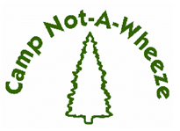
2024 Program Report

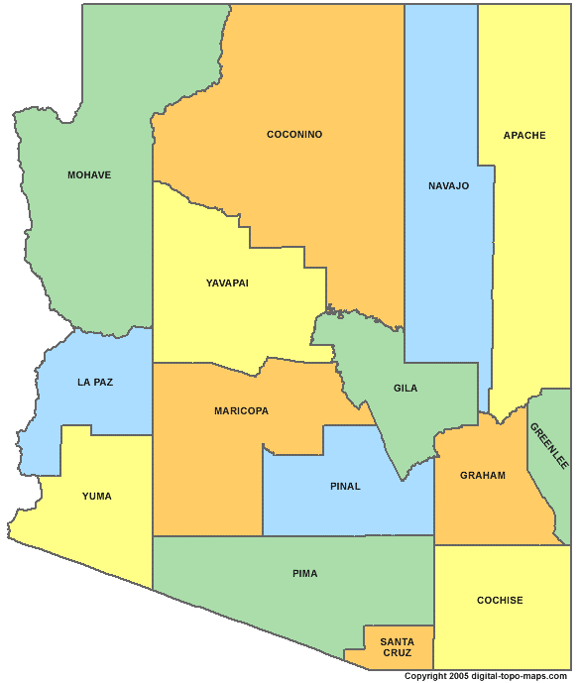
CAMPER DATA
53%
17%
RR, NM
1.5%
Table #1 Camper Home Location by County

County | # of Campers | Percentage
Pinal | 10 | 15%
Maricopa | 35 | 53%
Yuma | 1 | 1.5%
Mohave | 0 | 0%
Navajo | 6 | 9%
Pima | 11 | 17%
Coconino | 1 | 1.5%
Yavapai | 1 | 1.5%
Rio Rancho, NM | 1 | 1.5%
Total | 66 | 100%
* Data Source: Camp Not-A-Wheeze 2024 Camper
1.5%
1.5%
1.5%
6%
15%
0%
applications.

Table #2 Camper Ethnicity/Race

Ethnicity/Race | # of Campers | Percentage
Hispanic or Latino | 24 | 36%
Native American | 6 | 9%
Non-Hispanic, White | 29 | 44%
Black or African American | 7 | 11%
Total | 66 | 100%
* Data Source: Camp Not-A-Wheeze 2024 Camper
Applications.

Table #3 Gender Distribution

Gender | # of Campers | Percentage
Female | 30 | 45%
Male | 36 | 55%
Total | 66 | 100%
*Data Source: Camp Not-A-Wheeze 2024 Camper Applications.

Table #4 Age Distribution

Age | # of Campers | Percentage
7 years old | 1 | 1%
8 years old | 9 | 15%
9 years old | 10 | 16%
10 years old | 14 | 23%
11 years old | 4 | 7%
12 years old | 9 | 15%
13 years old | 10 | 16%
14 years old | 4 | 7%
Total | 61 | 100%
* Data Source: Camp Not-A-Wheeze 2024 Camper
Applications. Does not include the ages of the CIT’s

Table #5 Camper Annual Income

Household Annual Income in USD | # of Camper Families | Percentage
0-20,000 | 7 | 11%
20,000 – 30,000 | 4 | 6%
30,000 – 40,000 | 5 | 7%
40,000 – 50,000 | 9 | 14%
50,000 – 60,000 | 6 | 9%
60,000-70,000 | 2 | 3%
70,000-80,000 | 1 | 2%
80,000-90,000 | 6 | 9%
90,000-100,000 | 0 | 0%
>100,000 | 10 | 15%
Unknown | 16 | 24%
Total | 66 | 100%

* Data Source: Camp Not-A-Wheeze 2024 Campership Applications.

Table #6 Camper Health Insurance

Health Insurance | # of Campers | Percentage
AHCCCS | 30 | 46%
Private Health Insurance | 32 | 48%
Native American Health Services | 4 | 6%
Total | 66 | 100%
Data Source: Camp Not-A-Wheeze 2024 Camper
Applications.

Table #7 Campers on Scholarship

Scholarship | # of Campers | Percentage
Received Scholarship | 34 | 52%
Financial Discount | 14 | 21%
Did Not Qualify or Request a Scholarship | 18 | 27%
Total | 66 | 100%
* Scholarships are granted based on information provided
in Camp Not-A-Wheeze 2024 Campership Applications.

Table #8 New Campers vs Previous Campers

Has Child Attended CNAW in Previous Years | # of Campers | Percentage
Yes | 34 | 52%
No | 32 | 48%
Total | 66 | 100%
Data Source: Camp Not-A-Wheeze 2024 Camper
Applications.

Table #9 Increase in Asthma and Allergy Education in Campers CNAW 2024
* Data Source: Camp Not-A-Wheeze 2024 Camper Pre- and Post-Asthma and Allergy Education Evaluations.
Asthma and Allergy Education | Average % Correct Pre |  | Average %Correct Post | % Change
Disease/Anatomy/Physiology | 80.9% | 94.4% |  | 16.7%
Environment (Symptoms/Triggers/Allergens) | 80.9% | 93.5% |  | 15.6%
Medication | 84.7% | 95.6% |  | 12.8%
Management | 72.6% | 86.9% |  | 19.8%

