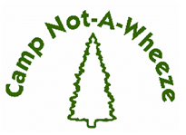
2023 Program Report

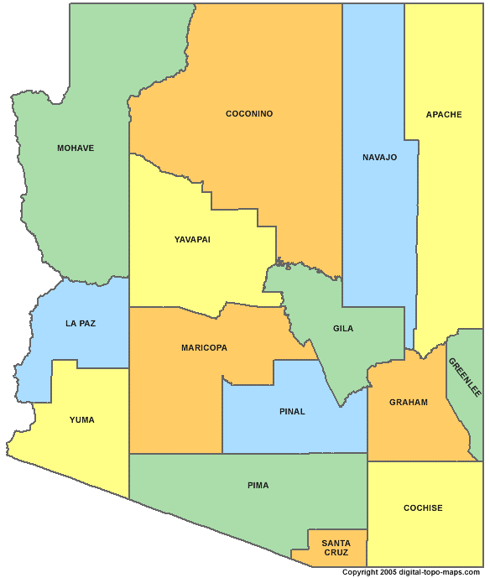
CAMPER DATA
72%
9%
RR, NM
2%
Table #1 Camper Home Location by County

County | # of Campers | Percentage
Pinal | 3 | 6%
Maricopa | 39 | 72%
Mohave | 1 | 2%
Navajo | 4 | 7%
Pima | 5 | 9%
Yavapai | 1 | 2%
Rio Rancho, NM | 1 | 2%
Total | 54 | 100%
* Data Source: Camp Not-A-Wheeze 2023 Camper
7%
6%
2%
2%
applications.

Table #2 Camper Ethnicity/Race

Ethnicity/Race | # of Campers | Percentage
Hispanic or Latino | 13 | 24%
Native American | 6 | 11%
Non-Hispanic, White | 24 | 44%
Black or African American | 9 | 17%
Asian | 0 | 0%
More than 1 Identified | 2 | 4%
Total | 54 | 100%
* Data Source: Camp Not-A-Wheeze 2023 Camper
Applications.

Table #3 Gender Distribution

Gender | # of Campers | Percentage
Female | 20 | 37%
Male | 34 | 63%
Total | 54 | 100%
*Data Source: Camp Not-A-Wheeze 2023 Camper Applications.

Table #4 Age Distribution

Age | # of Campers | Percentage
7 years old | 4 | 7%
8 years old | 6 | 11%
9 years old | 10 | 19%
10 years old | 9 | 17%
11 years old | 7 | 13%
12 years old | 7 | 13%
13 years old | 7 | 13%
14 years old | 4 | 7%
Total | 54 | 100%
* Data Source: Camp Not-A-Wheeze 2023 Camper
Applications.

Table #5 Camper Annual Income

Household Annual Income in USD | # of Camper Families | Percentage
<10,000 | 2 | 4%
10,000 – 20,000 | 3 | 6%
20,000 – 30,000 | 3 | 6%
30,000 – 40,000 | 7 | 13%
40,000 – 50,000 | 7 | 13%
> 50,000 | 27 | 49%
Unknown | 5 | 9%
Total | 54 | 100%

* Data Source: Camp Not-A-Wheeze 2023 Campership Applications.

Table #6 Camper Health Insurance

Health Insurance | # of Campers | Percentage
AHCCCS | 13 | 24%
Private Health Insurance | 37 | 69%
Native American Health Services | 4 | 7%
Total | 54 | 100%
Data Source: Camp Not-A-Wheeze 2023 Camper
Applications.

Table #7 Campers on Scholarship

Scholarship | # of Campers | Percentage
Received Scholarship | 37 | 69%
Did Not Qualify or Request a Scholarship | 17 | 31%
Total | 54 | 100%
* Scholarships are granted based on information provided
in Camp Not-A-Wheeze 2023 Campership Applications.

Table #8 New Campers vs Previous Campers

Has Child Attended CNAW in Previous Years | # of Campers | Percentage
Yes | 22 | 41%
No | 32 | 59%
Total | 54 | 100%
Data Source: Camp Not-A-Wheeze 2023 Camper
Applications.

Table #9 Increase in Asthma Education in Campers CNAW 2023

Asthma Education | Average % Correct Pre | Average %Correct Post | % Increase
Triggers | 73% | 93 | 20%
Etiology | 57% | 79% | 22%
Medication | 58% | 75% | 16%
Management | 73% | 87% | 14%
* Data Source: Camp Not-A-Wheeze 2023 Camper Pre- and Post-Asthma Education Evaluations.

